Checkout

What is Checkout?
# Source: AI Source: Provided by: [Data Path: Persons Table -> ID Column: 1, Name_En Column: Motasem Essam] -> From: [ChatGPT] on [2/15/2026]
In Git, checkout means switching to another branch or restoring files from the repository.
It has two main uses:

1. Switch between branches
# Source: AI Source: Provided by: [Data Path: Persons Table -> ID Column: 1, Name_En Column: Motasem Essam] -> From: [ChatGPT] on [2/15/2026]
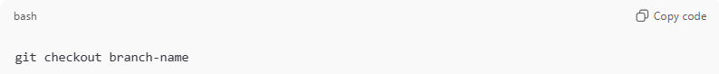
git checkout branch-name
This moves you from your current branch to another branch.
Example
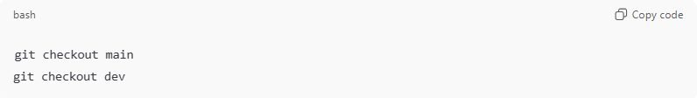
git checkout main
git checkout dev
Git changes:
- Working directory files → updated to that branch
- HEAD → now points to the new branch

2. Restore file(s) from a commit
# Source: AI Source: Provided by: [Data Path: Persons Table -> ID Column: 1, Name_En Column: Motasem Essam] -> From: [ChatGPT] on [2/15/2026]
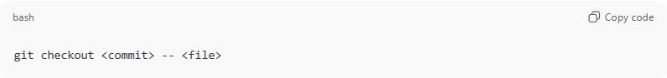
git checkout <commit> -- <file>
This replaces the file in your working directory with the version from that commit.
Example
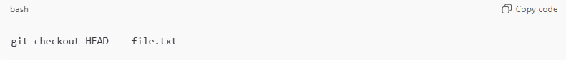
git checkout HEAD -- file.txt
Restore file to last committed version (undo local changes).

Detached HEAD (important)
# Source: AI Source: Provided by: [Data Path: Persons Table -> ID Column: 1, Name_En Column: Motasem Essam] -> From: [ChatGPT] on [2/15/2026]
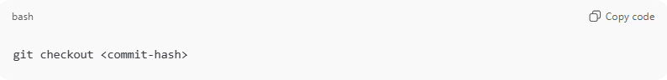
git checkout <commit-hash>
You move to a specific commit, not a branch.
- HEAD points directly to a commit
- You are in detached HEAD state
- New commits here are not on any branch (can be lost if not saved)
To save work:
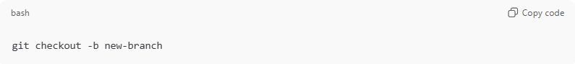
git checkout -b new-branch

Modern Git (recommended)
# Source: AI Source: Provided by: [Data Path: Persons Table -> ID Column: 1, Name_En Column: Motasem Essam] -> From: [ChatGPT] on [2/15/2026]
Git split checkout into two clearer commands:
Switch branches
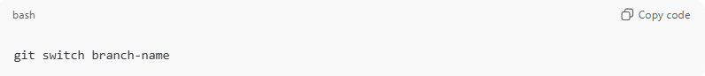
git switch branch-name
Restore files
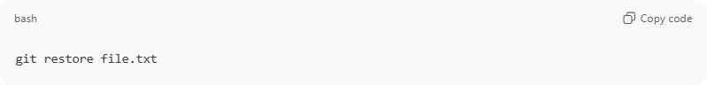
git restore file.txt
But checkout still works and is widely used.

Quick summary
# Source: AI Source: Provided by: [Data Path: Persons Table -> ID Column: 1, Name_En Column: Motasem Essam] -> From: [ChatGPT] on [2/15/2026]
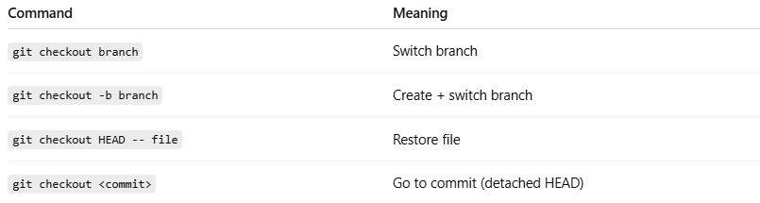
Command | Meaning
git checkout branch | Switch branch
git checkout -b branch | Create + switch branch
git checkout HEAD -- file | Restore file
git checkout <commit> | Go to commit (detached HEAD)

